PA46/Avidyne System Calibration Procedure

Version 1.01 11/3/2020
Cies Corp

It’s your lucky day..NOT! Unfortunately, the PA46/Avidyne combination is by far one of the hardest systems to calibrate. But, after a handful of service calls, I think I’ve managed to take most of the pain out of the calibration procedure.

Most modern Flight Systems allow you to calibrate the Flight System to match the Fuel Sender. This is normally done by placing the Flight System into a calibration mode and then filling the tank with unusable fuel and pressing a button on the Flight System, then adding 5 gals, and again pressing a button on the Flight System. This procedure is repeated until the tank is fill. Thus, providing a calibration point every 5 gals.

On the Avidyne, you can only calibrate the system at Empty (unusable fuel) and Full. The Avidyne system then has a built-in calibration curve that “should” match the output from the OEM Sender at levels between empty and full – You hope!

As the Avidyne can not be calibrated at multiple points (i.e., every 5 gallons), we are going calibrate the Sender to the Avidyne. This will be done by generating a “calibration profile” and then uploading the profile to the Sender using the CiES Programming Unit.

In order to generate the Calibration Profile, we need to create a Calibration Table:

Fuel (Gallons) | Frequency | Index | Setpoint Volts
Empty (no fuel)
0 (Unusable)
5
10
15
20
25
30
35
40
45
50
55
56
57
58
59
60

The above calibration table will be created in two steps.

Step1:

In this step, we will record the output frequency of the Inboard Sender for each row of the calibration table. This will be done by connecting running the Blue wire from the Inboard Sender out the fuel cap.

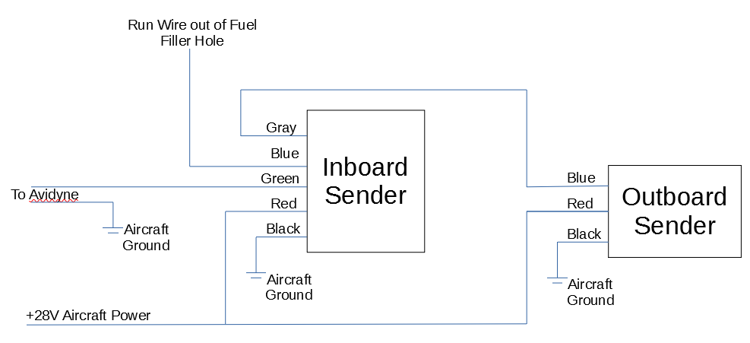
NOTE: For best results, the Black wire of each Sender should be grounded to the Aircraft Chassis as close as possible to the Sender.

Now, connect the Laptop/Programming Unit as shown:

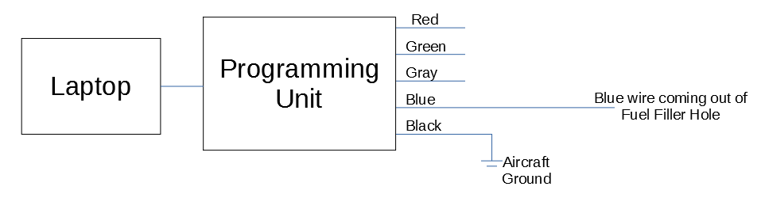

Make sure Programming Unit is plugged into Laptop, then turn on Laptop and start Programming Software. The LED’s inside of the USB Cable of the Programming Unit should start flashing.

Now, double-click on the CiES Logo, this should display additional “tabs” as shown in Figure 2.
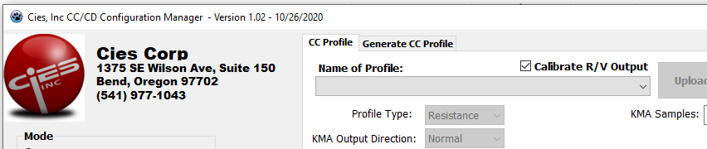Figure 1: Before Double-Clicking on the CiES Logo
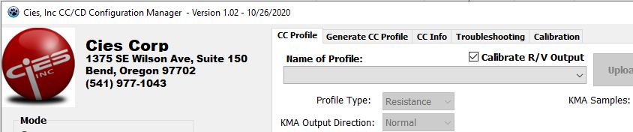Figure 2: After Double-Clicking on the CiES Logo
Now, click on the Troubleshooting tab and chage the Digital Mode for DIG_IO1 to DIG_FREQ_IN (See Figure 3 below).
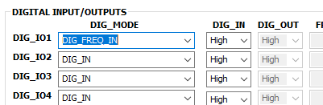Figure 3: DIG_MODE for DIG_IO1 as been changed to DIG_FREQ_IN

Next, change the Slave Units from No Slaves to 1 Slave:
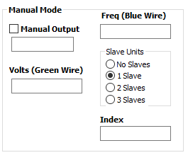Figure 4: Change Slave Units to 1 Slave

Now turn on Aircraft Power. If everything is functioning correctly, you should see a frequency value in the “Freq (Blue Wire)” box and an index value in the “Index” box.

As there is no fuel in the tank, enter the Frequency and Index into the Calibration Table in the “Empty” row.

Add unusable fuel and record the Frequency and Index for “0 (Unusable)”.

Now, add 5 more gals and record Frequency and Index. Repeat this process to 55 gals. After 55 Gals, add 1 gallon at a time until tank is complete full.

